Riot API Challenge

“URF Quest”
Game Design Document

Team:
Matthew Baker – mrriktor@gmail.com
Vincent Biancardi - ???
Table Of Contents

Story
Purpose
Gameplay
Executive Summary

High Concept
By choosing a team from a random group of matches, fight your way through 10 stages of minions and monsters familiar with summoner's rift in order earn the right to fight the final boss... URF the Manatee.

Locale
The game takes place on the Summoner's Rift of League of Legends.

Basic Controls
The player will navigate the game by selecting options and dragging and dropping objects using the mouse.

Game Goal
Defeat all 10 stages by choosing the best team based upon the stats of the players in the randomly retrieved URF matches.

Target Platform
Unity Webplayer

Game Overview
The player is presented with a list of random matches from URF games. The player will select the match that they feel will be able to progress the farthest based upon the overall attack and health of the team. Once a team is selected the player will enter the rift and battle minions, progressing through the jungle camps, dragon, baron and finally fighting URF. Battle is done through a turned based system that is entirely driven by AI. Initiative is determined by the base movement speed of the champion currently attacking. If the champion defeats a unit, they are given a stacking movement speed debuff. This ensures that no champion with insane movement speed can attack first and never be hit, preventing a clean sweep without any damage being taken. If the player successfully defeats all stages they will win the game.

User Interaction

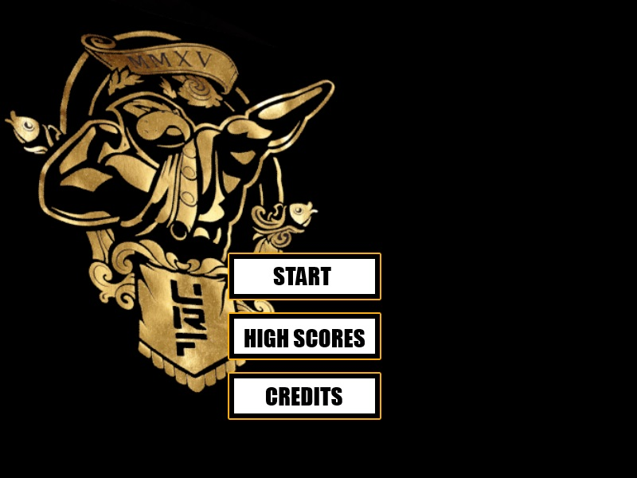
Main Menu Screen

The main menu screen is where the player is put when the application loads. The player is presented with the option to start the game, view high scores or view the applications credits.

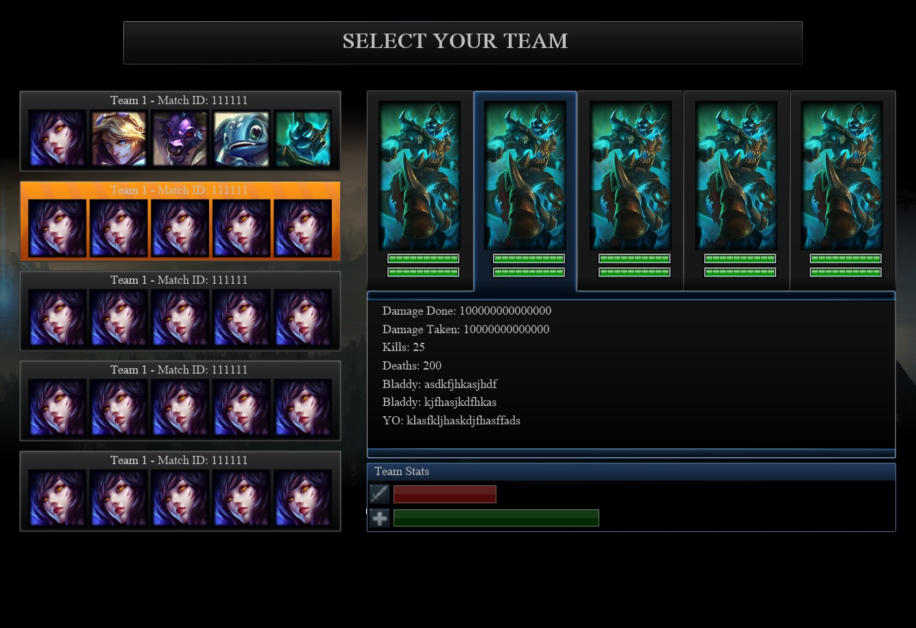
Team Selection Screen

The team selection screen is where the player will select from the matches retrieved for them to use. These matches are retrieved from a pool of matches played within the last 8 hours. The exact functionality that defines the pool of matches that the list is populated with is still being determined.

Progression Screen
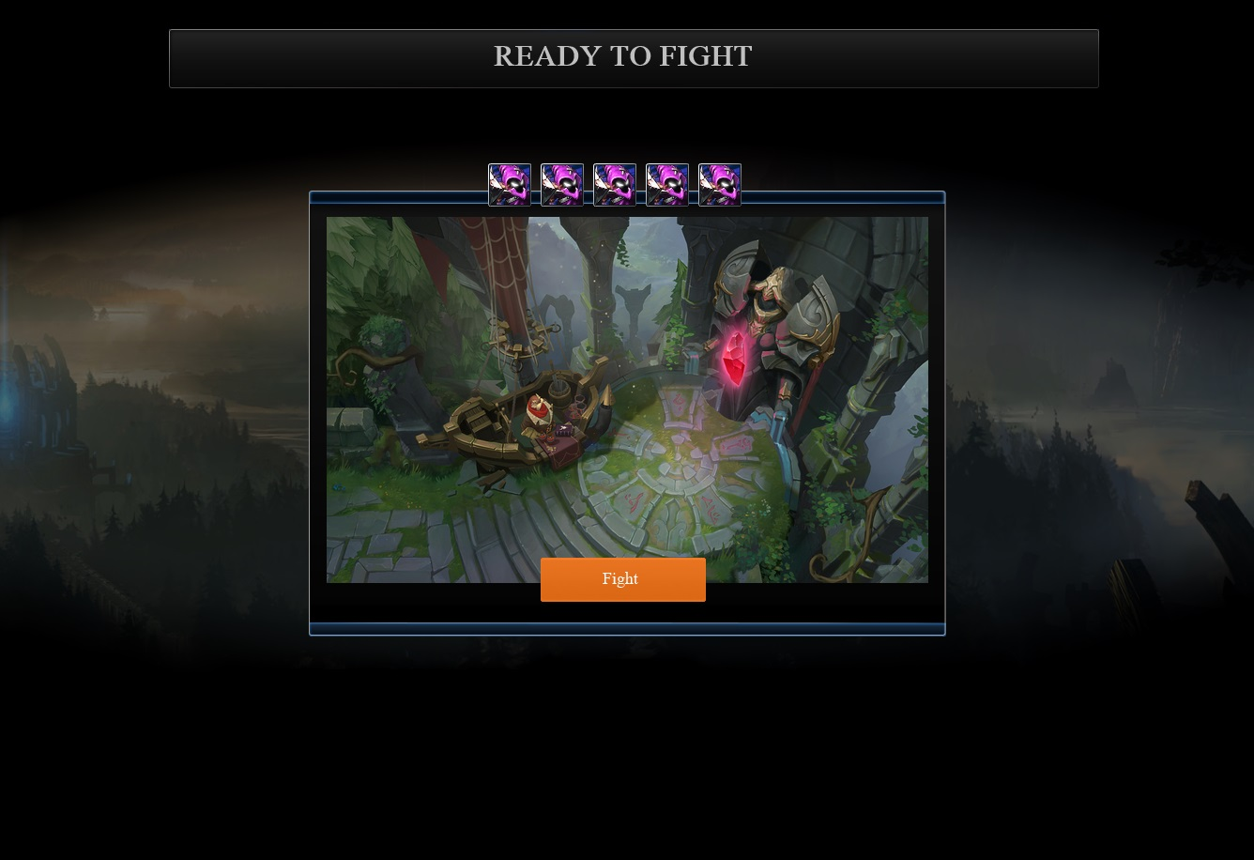
The progression screen shows a screen capture of the area of summoners rift you are entering for battle. The enemies that are in that stage are shown at the top of the screen.

Battle Screen
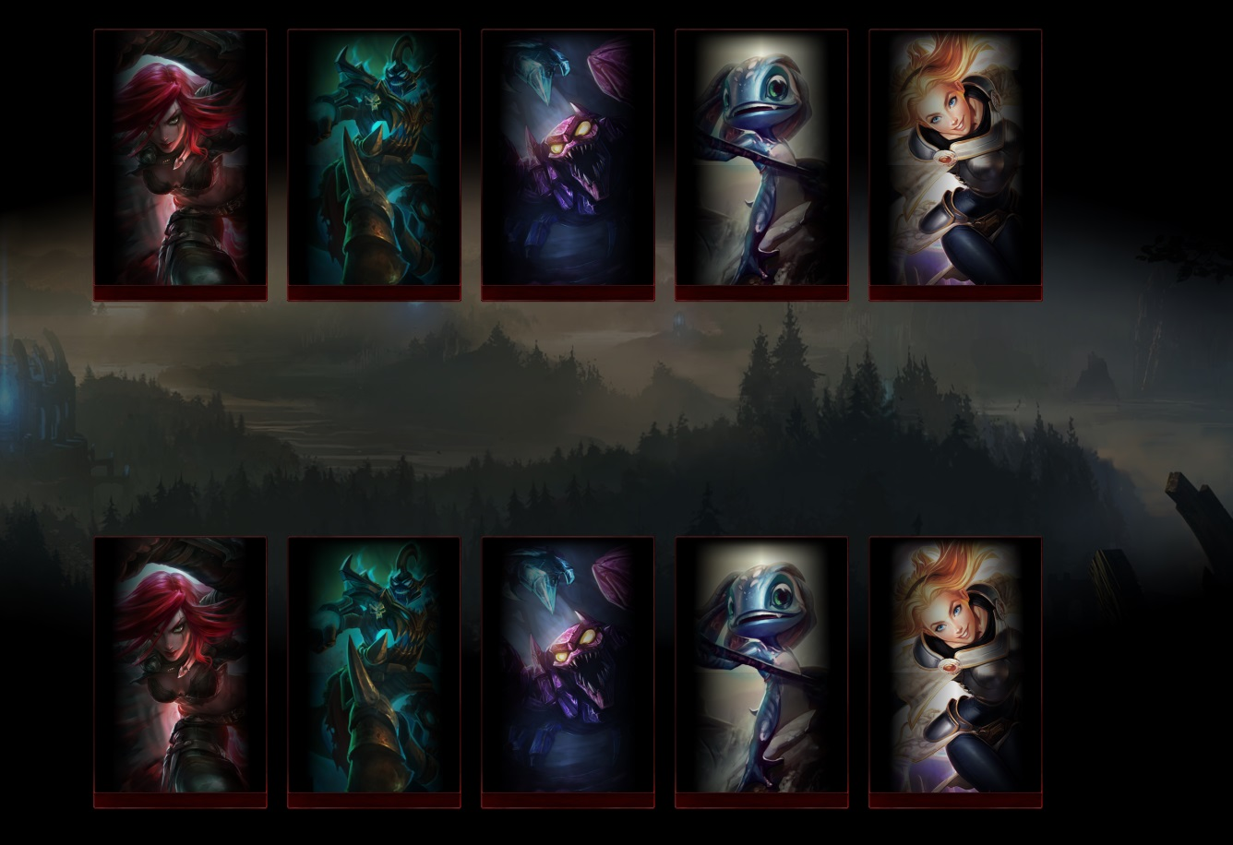
The battle screen shows the team you have picked and the group you are going up against. The way the match progresses is from left to right, your champions and the enemy minions take turns attacking. If an enemy, or your champion are reduced to zero HP the portrait is grayed out and the next champion or minion in the line is moved to the attacking position. When all minions or champions are dead, the winner and loser are shown their respective win or loss screens. If the player wins, they are returned to the “progression screen” and the next level is traversed to. If the player loses, the same level will be displayed and a strike will be given to the user.

TODO: Finish document from here.

Character

- Gameplay
  - Starting the Game
    - The player is presented with a list of Random Matches retrieved from the Riot API and is told to choose a “team” in which to progress through the rift.
    - The player is given the option to position champions in different attack slots for when combat begins.
  - Match Fighting
    - The team selected by the player is then pitted against the minions of their current level of progression.
    - Minions have a static base Attack and HP pools depending on the type of minion.
    - Champions and Minions trade off attacking, initiative is given to the champion or minion with the highest base movement speed. (Based upon champions base movement speed.) Minion movement speed is based upon the average movement speed of all champions and how fast the developers felt the minions should be.
    - If the player's champion pool is defeated, they will lose the match.
    - In order for the player to win a match, they must defeat all minions in that level by reducing all of the minions health to 0 before going through their teams champion pool.
  - Win/Lose Conditions
    - Players will lose the game when they failed to defeat a level.
    - Players will win the game if they defeat all of the levels.
    - Scores will be stored based upon success and how well the player did in the 10 matches they won.

